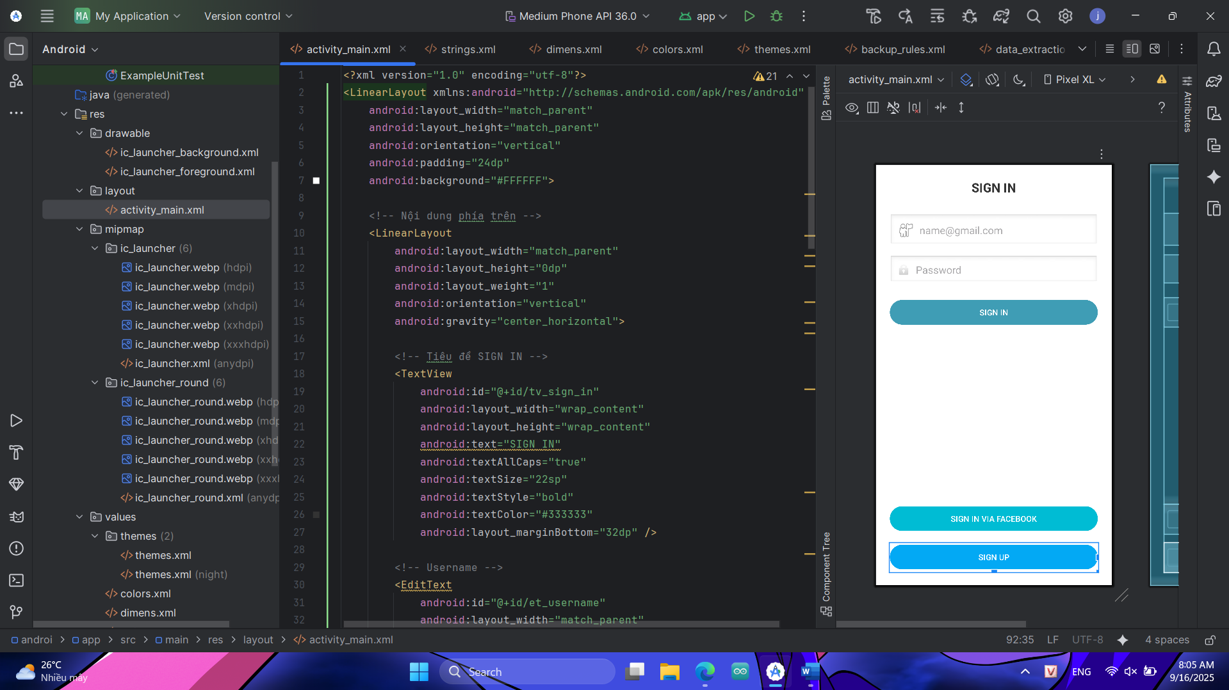

Nội dung file activity_main.xml

<?xml version="1.0" encoding="utf-8"?>  
<LinearLayout xmlns:android="http://schemas.android.com/apk/res/android"  
 android:layout_width="match_parent"  
 android:layout_height="match_parent"  
 android:orientation="vertical"  
 android:padding="24dp"  
 android:background="#FFFFFF">  
  
 <!-- Nội dung phía trên -->  
 <LinearLayout  
 android:layout_width="match_parent"  
 android:layout_height="0dp"  
 android:layout_weight="1"  
 android:orientation="vertical"  
 android:gravity="center_horizontal">  
  
 <!-- Tiêu đề SIGN IN -->  
 <TextView  
 android:id="@+id/tv_sign_in"  
 android:layout_width="wrap_content"  
 android:layout_height="wrap_content"  
 android:text="SIGN IN"  
 android:textAllCaps="true"  
 android:textSize="22sp"  
 android:textStyle="bold"  
 android:textColor="#333333"  
 android:layout_marginBottom="32dp" />  
  
 <!-- Username -->  
 <EditText  
 android:id="@+id/et_username"  
 android:layout_width="match_parent"  
 android:layout_height="wrap_content"  
 android:hint="name@gmail.com"  
 android:inputType="textEmailAddress"  
 android:drawableLeft="@android:drawable/ic_menu_myplaces"  
 android:drawablePadding="8dp"  
 android:background="@android:drawable/edit_text"  
 android:padding="12dp"  
 android:layout_marginBottom="16dp" />  
  
 <!-- Password -->  
 <EditText  
 android:id="@+id/et_password"  
 android:layout_width="match_parent"  
 android:layout_height="wrap_content"  
 android:hint="Password"  
 android:inputType="textPassword"  
 android:drawableLeft="@android:drawable/ic_lock_idle_lock"  
 android:drawablePadding="8dp"  
 android:background="@android:drawable/edit_text"  
 android:padding="12dp"  
 android:layout_marginBottom="24dp" />  
  
 <!-- Nút SIGN IN -->  
 <Button  
 android:id="@+id/btn_sign_in"  
 android:layout_width="match_parent"  
 android:layout_height="wrap_content"  
 android:text="SIGN IN"  
 android:textAllCaps="true"  
 android:backgroundTint="#3F9DB5"  
 android:textColor="#FFFFFF"  
 android:layout_marginBottom="24dp"  
 android:padding="12dp" />  
 </LinearLayout>  
  
 <!-- Các nút dưới cùng -->  
 <LinearLayout  
 android:layout_width="match_parent"  
 android:layout_height="wrap_content"  
 android:orientation="vertical"  
 android:gravity="center">  
  
 <!-- Nút SIGN IN VIA FACEBOOK -->  
 <Button  
 android:id="@+id/btn_facebook"  
 android:layout_width="match_parent"  
 android:layout_height="wrap_content"  
 android:text="SIGN IN VIA FACEBOOK"  
 android:textAllCaps="true"  
 android:backgroundTint="#00BCD4"  
 android:textColor="#FFFFFF"  
 android:layout_marginBottom="16dp"  
 android:padding="12dp" />  
  
 <!-- Nút SIGN UP -->  
 <Button  
 android:id="@+id/btn_sign_up"  
 android:layout_width="match_parent"  
 android:layout_height="wrap_content"  
 android:text="SIGN UP"  
 android:textAllCaps="true"  
 android:backgroundTint="#03A9F4"  
 android:textColor="#FFFFFF"  
 android:padding="12dp" />  
 </LinearLayout>  
  
</LinearLayout>

ContraintLayout

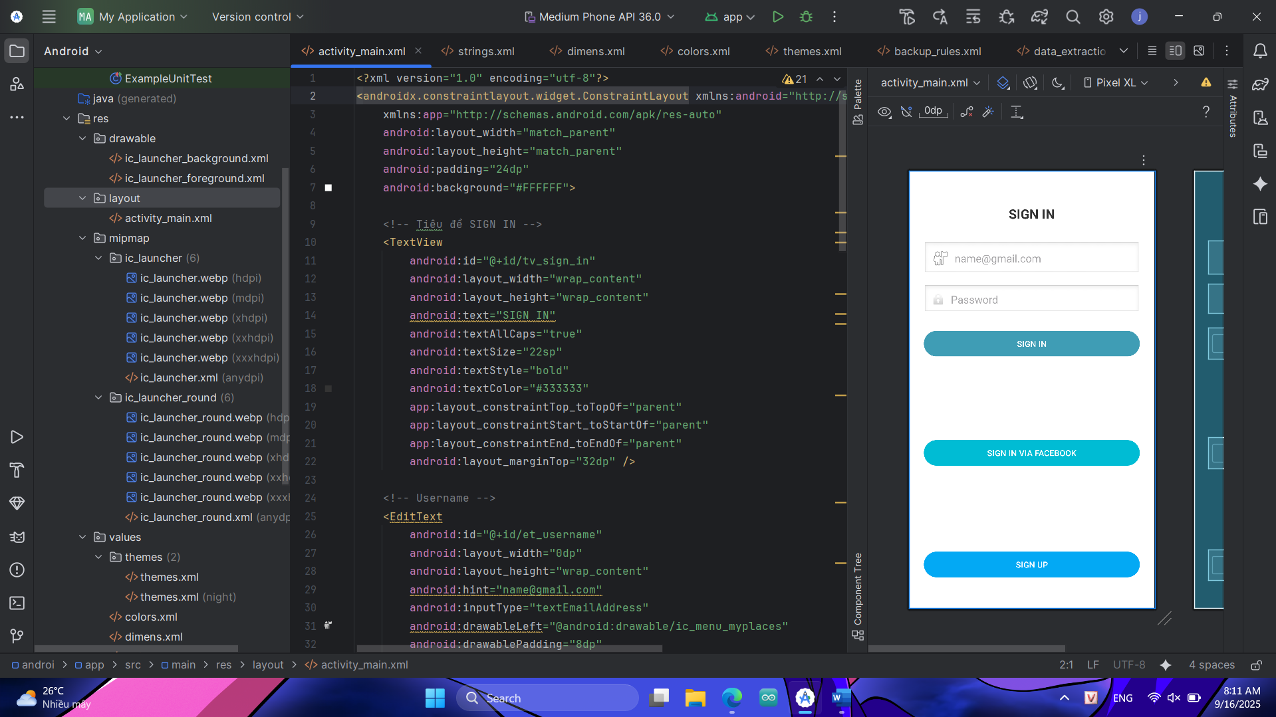

<?xml version="1.0" encoding="utf-8"?>

<androidx.constraintlayout.widget.ConstraintLayout xmlns:android="http://schemas.android.com/apk/res/android"

xmlns:app="http://schemas.android.com/apk/res-auto"

android:layout_width="match_parent"

android:layout_height="match_parent"

android:padding="24dp"

android:background="#FFFFFF">

<!-- Tiêu đề SIGN IN -->

<TextView

android:id="@+id/tv_sign_in"

android:layout_width="wrap_content"

android:layout_height="wrap_content"

android:text="SIGN IN"

android:textAllCaps="true"

android:textSize="22sp"

android:textStyle="bold"

android:textColor="#333333"

app:layout_constraintTop_toTopOf="parent"

app:layout_constraintStart_toStartOf="parent"

app:layout_constraintEnd_toEndOf="parent"

android:layout_marginTop="32dp" />

<!-- Username -->

<EditText

android:id="@+id/et_username"

android:layout_width="0dp"

android:layout_height="wrap_content"

android:hint="name@gmail.com"

android:inputType="textEmailAddress"

android:drawableLeft="@android:drawable/ic_menu_myplaces"

android:drawablePadding="8dp"

android:background="@android:drawable/edit_text"

android:padding="12dp"

app:layout_constraintTop_toBottomOf="@id/tv_sign_in"

app:layout_constraintStart_toStartOf="parent"

app:layout_constraintEnd_toEndOf="parent"

android:layout_marginTop="32dp" />

<!-- Password -->

<EditText

android:id="@+id/et_password"

android:layout_width="0dp"

android:layout_height="wrap_content"

android:hint="Password"

android:inputType="textPassword"

android:drawableLeft="@android:drawable/ic_lock_idle_lock"

android:drawablePadding="8dp"

android:background="@android:drawable/edit_text"

android:padding="12dp"

app:layout_constraintTop_toBottomOf="@id/et_username"

app:layout_constraintStart_toStartOf="parent"

app:layout_constraintEnd_toEndOf="parent"

android:layout_marginTop="16dp" />

<!-- Nút SIGN IN -->

<Button

android:id="@+id/btn_sign_in"

android:layout_width="0dp"

android:layout_height="wrap_content"

android:text="SIGN IN"

android:textAllCaps="true"

android:backgroundTint="#3F9DB5"

android:textColor="#FFFFFF"

android:padding="12dp"

app:layout_constraintTop_toBottomOf="@id/et_password"

app:layout_constraintStart_toStartOf="parent"

app:layout_constraintEnd_toEndOf="parent"

android:layout_marginTop="24dp" />

<!-- Nút SIGN IN VIA FACEBOOK -->

<Button

android:id="@+id/btn_facebook"

android:layout_width="0dp"

android:layout_height="wrap_content"

android:text="SIGN IN VIA FACEBOOK"

android:textAllCaps="true"

android:backgroundTint="#00BCD4"

android:textColor="#FFFFFF"

android:padding="12dp"

app:layout_constraintBottom_toTopOf="@id/btn_sign_up"

app:layout_constraintStart_toStartOf="parent"

app:layout_constraintEnd_toEndOf="parent"

android:layout_marginBottom="16dp" />

<!-- Nút SIGN UP -->

<Button

android:id="@+id/btn_sign_up"

android:layout_width="0dp"

android:layout_height="wrap_content"

android:text="SIGN UP"

android:textAllCaps="true"

android:backgroundTint="#03A9F4"

android:textColor="#FFFFFF"

android:padding="12dp"

app:layout_constraintBottom_toBottomOf="parent"

app:layout_constraintStart_toStartOf="parent"

app:layout_constraintEnd_toEndOf="parent"

android:layout_marginBottom="24dp" />

</androidx.constraintlayout.widget.ConstraintLayout>